Phase Change Lab
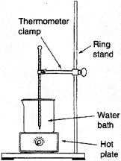
Materials
- Thermometer
- Thermometer clamp
- Ring Stand
- Hot Plate
- Styrofoam cup
- 400 mL Beaker
- Ice
- Stopwatch

Procedure
Use the setup to the right to set up your experiment. Your goal is to investigate the phase change of water by recording temperature at different times while heating the ice in the beaker. Before doing this experiment, design your plan for accomplishing this goal and inform your instructor of your plan before you begin. MAKE SURE YOU RECORD THE TERMPERATURE AT TIME = 0 SECONDS. It will help you to set up some sort of table to analyze your data. When you are done with your experiment, graph your results on a piece of graph paper (make sure you put the correct data on each axis! Think of independent and dependent variables). After you have graphed the data, answer the question below.
Analysis
What happened to the temperature as the ice melted? As the water boiled? (Make your temperature table here.)

Where do you think that the energy from the burner was going?

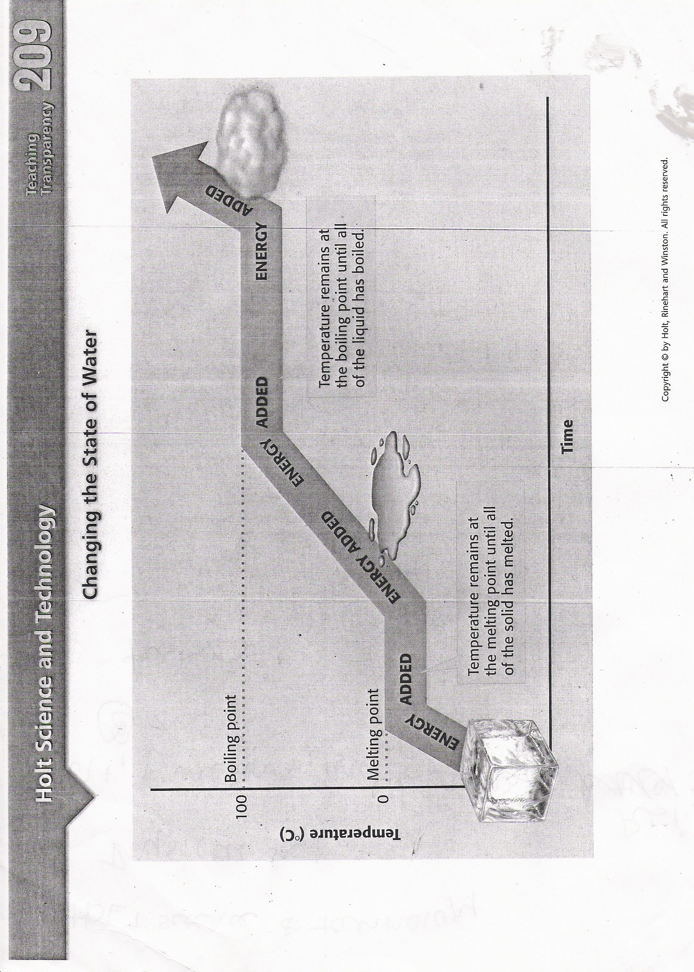
Day 4, Handout 2
Post-Lab Questions:
Analyze the Phase Diagram of an Unknown Substance

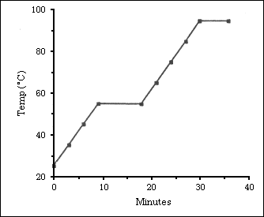
D

C

B

A

What is the melting point of the substance?

What is the boiling point of the substance?

What letter on the diagram indicates solid is present only?

What letter on the diagram indicates a gas is present only?

What letter on the diagram indicates a liquid is present only?

What letter on the diagram indicates both solid AND liquid are present?

