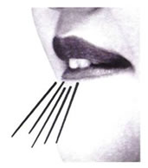 /f/
Placement: Where is your /f/ sound made?
- In the front part of your mouth
- Your top teeth and bottom lip come together
- Blow air out

Hints for how to help the child find placement:
- Tell them: “Bite your bottom lip real soft.”
- Say: “Show me your chipmunk face.”
- You can also refer to this as your “fan sound.” Pretend to fan your finger - hold your pointer finger in front of your mouth and use your /f/ sound to cool it off.
- You can refer to this sound as a “lip cooler.” You are like a fan cooling your lip off when you make this sound.

Sound Development Data:
90% of males acquire /f/ by age 3:6
90% of females acquire /f/ by age 3:6

