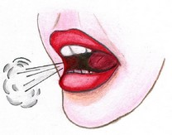
/k/
Placement: Where is your /k/ sound made?
- In the back of your mouth
- The back of the tongue raises up to the roof of your mouth
- Blow a short burst of air out

Hints for how to help the child find placement:
- Open your mouth wide and show them how you raise your tongue up. Model the /k/ sound so they can see and hear it. Practicing in front of a mirror helps.
- A tongue depressor can be used to help push the child’s tongue up and back.
- Have the child lay on their back on the floor. Once relaxed, gravity will help their tongue fall in the back of their mouth and they may have an easier time practicing /k/.
- You can refer to this sound as a “Tongue Scraper.” You are scraping the roof of your mouth to make this sound.
- Put a little peanut butter in the back roof of your child’s mouth to help practice raising their tongue in a scraping motion.

Sound Development Data:
90% of males acquire /k/ by age 3:6
90% of females acquire /k/ by age 3:6

