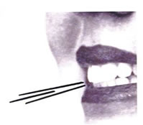
/s/
Placement: Where is your /s/ sound made?
- Put your tongue tip behind your top or bottom teeth (either one)

Hints for how to help the child find placement:
- Tell them: “Put the tip of your tongue right behind your teeth. Remember to keep your teeth together.”
- Tell them: “Lets pretend your tongue is a lion and your teeth are the lion’s cage. When you make your new /s/ sound, the lion has to stay behind the cage.”
- Say: “This sound is what a snake says. We can call it our ‘snake’ sound. Whenever we make this sound, let’s pretend our arm is a slithering snake.”

Sound Development Data:
90% of males acquire correct production of /s/ between ages 7:0-9:0
90% of females acquire correct production of /s/ between ages 7:0-9:0

