Transverse and Longitudinal Wave Practice

1. The highest point on a wave is the __________, while the lowest point is the __________.

2. The __________ of a wave is a measure of the amount of energy it carries.

3. The distance from one crest to the next crest is the __________.

4. The __________ is a measure of the number of waves that pass a point in a given amount of time.

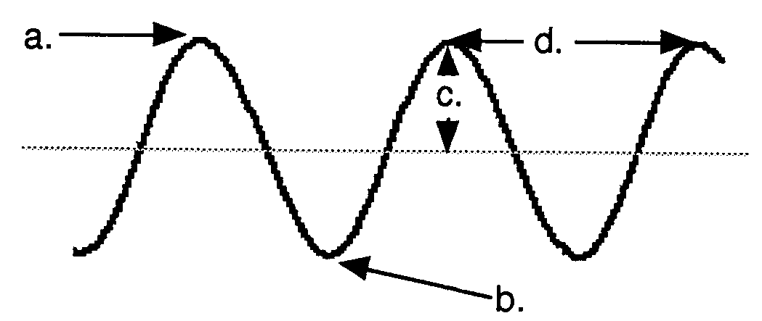
5. The illustration to the right shows a wave. Label each part in the space below:

a. ____________________

b. ____________________

c. ____________________

d. ____________________

6. Use the five illustrations of waves drawn below to answer the following questions:

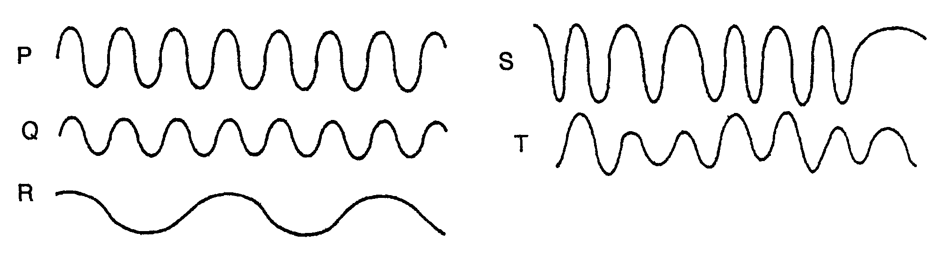

- Waves P and Q have the same __________, but wave P has twice the __________ of wave Q.

- Waves Q and R have the same __________, but wave R has twice the __________ of wave Q.

- Wave __________ shows a steady frequency but changing amplitude.

- Wave __________ shows steady amplitude but a changing frequency.

- Waves __________ and __________ have a low amplitude and a steady frequency.

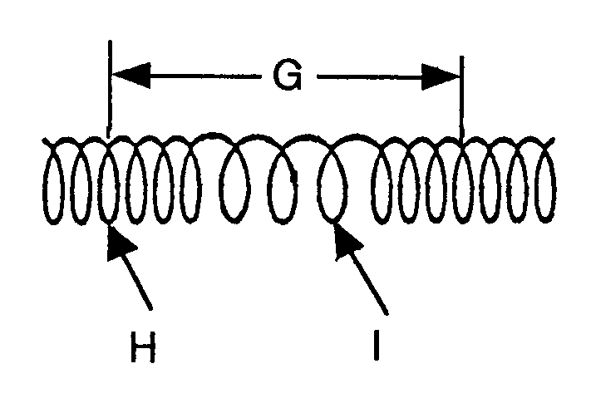
7. The following questions refer to the diagram to the right:

- Is this wave transverse or longitudinal?

- Letter H represents a _______________ and
letter I represents a _______________.

- Letter G represents a ______________.
WAVE SPEED PROBLEMS TO SOLVE
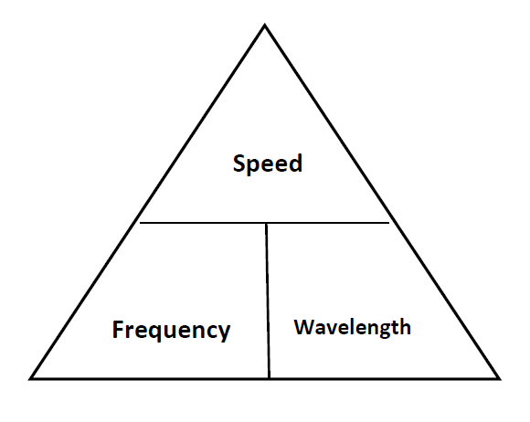
Remember: wave speed=wavelength*frequency v = λ * f
Variables, units, and symbols:
v = wave speed; units m/s (unless a different length is noted)
λ = wavelength; units meters (unless a different speed is noted)

f = frequency; units Hertz (Hz)

1. A wave with a frequency of 14 Hz has a wavelength of 3 meters. At what speed will this wave travel?

2. The speed of a wave is 65 m/sec. If the wavelength of the wave is 0.8 meters, what is the frequency of the wave?

3. A wave has a frequency of 46 Hz and a wavelength of 1.7 meters. What is the speed of this wave?

4. A wave traveling at 230 m/sec has a wavelength of 2.1 meters. What is the frequency of this wave?

5. A wave with a frequency of 500 Hz is traveling at a speed of 200 m/s. What is the wavelength?

6. A wave has a frequency of 540 Hz and is traveling at 340 m/s. What is its wavelength?

7. A wave has a wavelength of 125 meters and is moving at a speed of 20 m/s. What is its frequency?

8. A wave has a frequency of 900 Hz and a wavelength of 200 m. At what speed is this wave traveling?

9. A wave has a wavelength of 0.5 meters and a frequency of 120 Hz. What is the wave’s speed?

10. Radio waves travel at a speed of 300,000,000 m/s. WFNX broadcasts radio waves at a frequency of 101,700,000 Hz. What is the wavelength of WFNX’z radio waves?

